AI ASSISTED CODING

ASSIGNMENT-10.1

Name:S.Vrindha Reddy

Hall Number:2403A51255

Batch:11

**Task -1:**

**GIVEN CODE:**

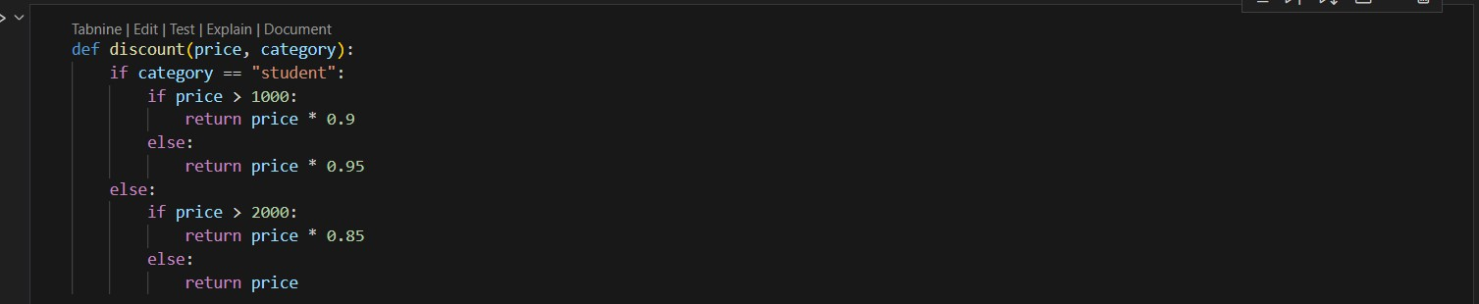

PROMPT:

For the above code simplify and refactor for readability.

CODE:

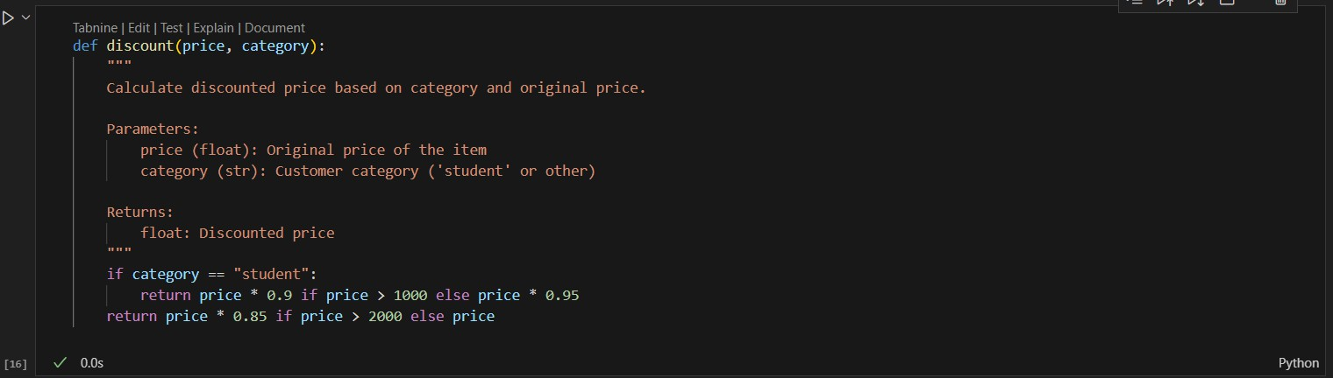

**Task-2:**

**GIVEN CODE:**

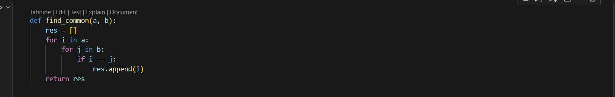

**PROMPT:**

Refactor and optimize the above code.

**AI GENERATED CODE:**

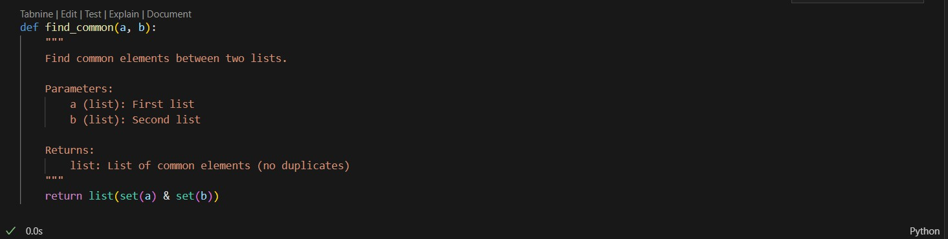

**TASK 3:**

**GIVEN CODE:**

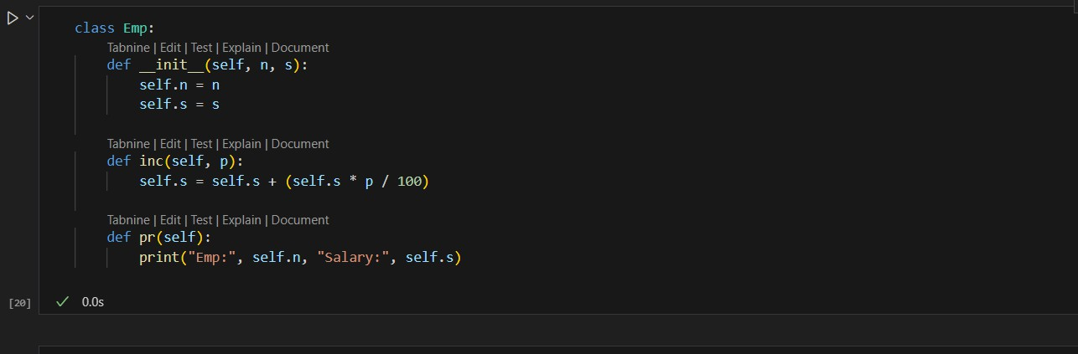

**PROMPT-**

For the above code improve Naming conventions, Encapsulation, Readability C maintainability.

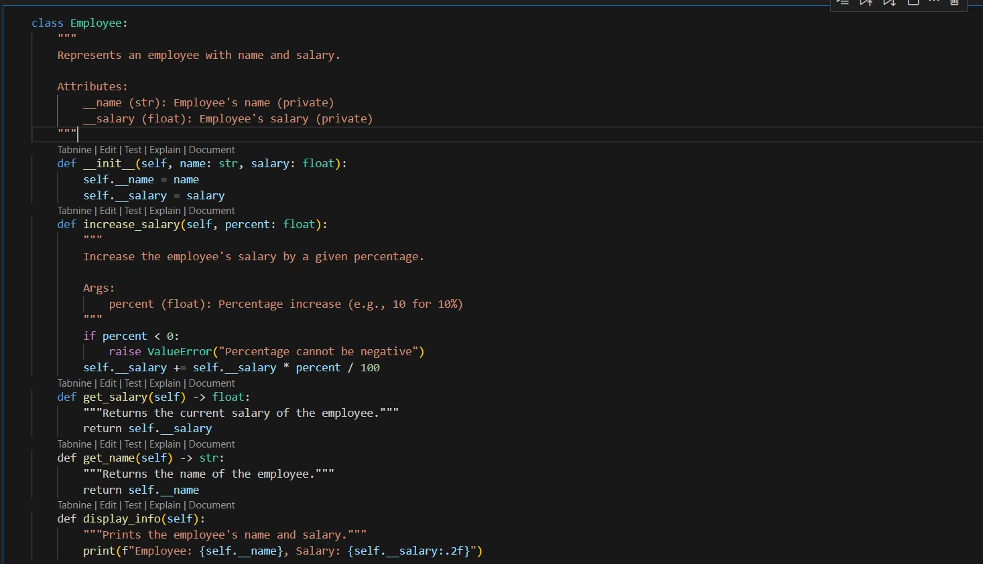

**TASK 4:**

**GIVEN CODE:**

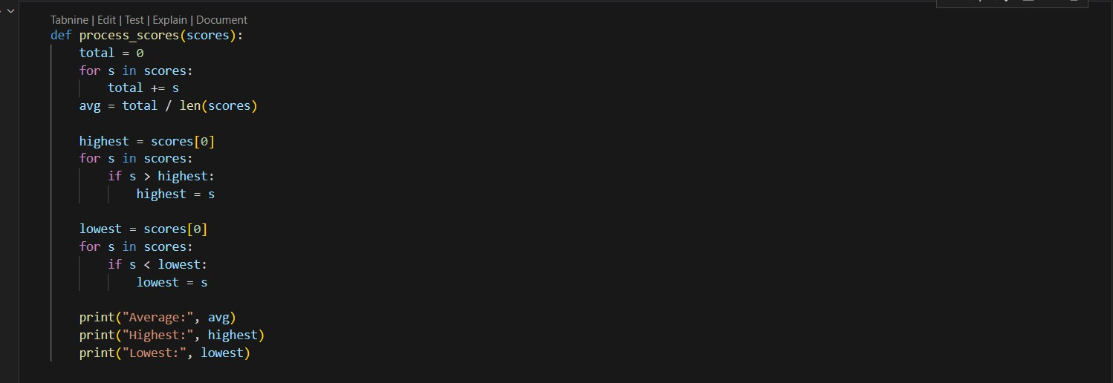

**PROMPT:**

Break the code into smaller helper functions.

**AI GENERATED CODE:**

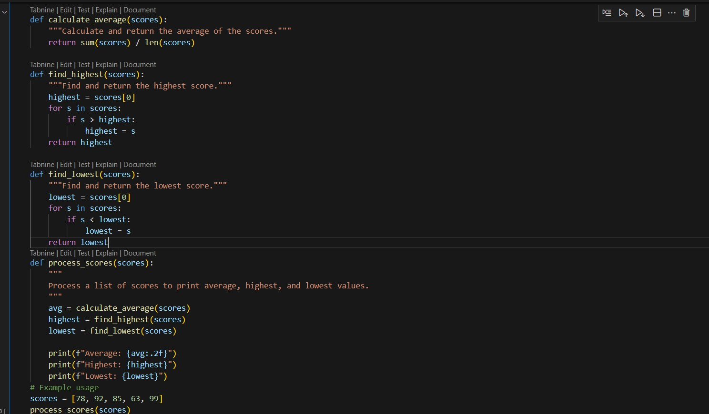

**OUTPUT-**



**TASK 5:**

**GIVEN CODE:**

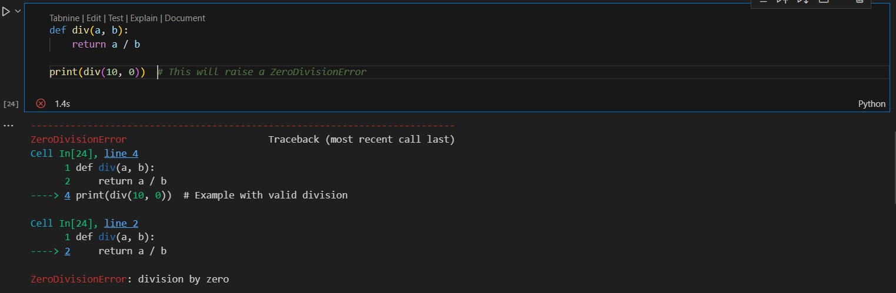

**PROMPT:**

For the above code improve error handling, naming, and readability.

**AI GENERATED CODE:**

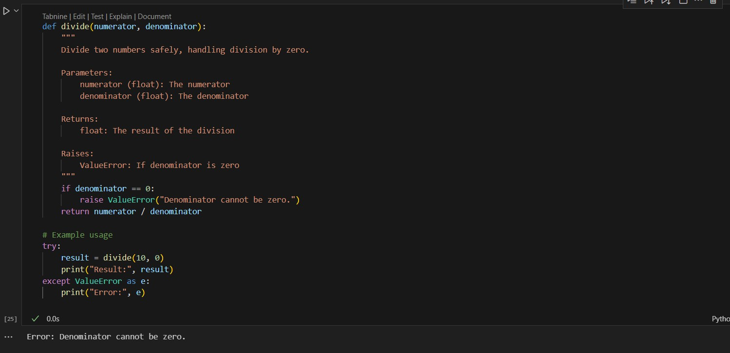

**TASK 6:**

**GIVEN CODE:**

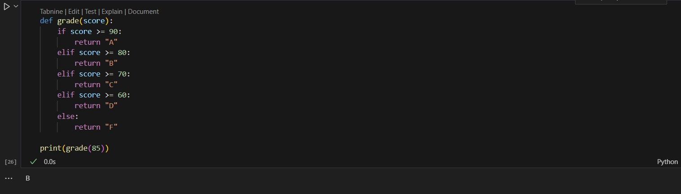

**PROMPT-**

Simplify overly complex logic.

**AI GENERATED CODE:**

